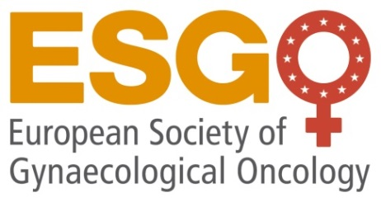

APPLICATION for ESGO Endorsement of Scientific Meeting

- Applicant’s details

1 | Name / surname
2 | Membership number (if applicable)

- Meeting description and contact details

1 | Country/City
2 | Venue
3 | Name of the meeting
4 | Date
5 | Expected number of participants
6 | Local Organizer (LO)  (Society/ Institute)
7 | Type of meeting | ☐ National society meeting  ☐ Academic meeting  ☐ Course  ☐ Other (please specify):
8 | Contact person (address, tel/fax, e-mail)

Endorsement of Scientific meetings by ESGO is governed by ESGO Rules for Endorsement of Scientific Meetings. For reference, please see ESGO Endorsement Guidelines in the Annex 1 to this Application Form, and confirm their acceptance bellow.
The scientific program of the meeting is a mandatory part of the application. ESGO may assist local organizers with composition of the scientific program if required, and propose participation of European speakers, ESGO members, to cover topics suggested by local organizers.
Specify type of requested endorsement:
Pure logo endorsement ☐
Joint session at sister society’s meeting ☐
ESGO session at a national/international meeting ☐
Suggestion of topics for ESGO speakers (if applicable)

Topic 1:

Topic 2:

Topic 3:

Others:

I confirm acceptance of terms and conditions of the ESGO Endorsement Guidelines
(Local Organizer input) please tick ☐

I confirm that I am ESGO member with activated membership, if relevant please tick ☐

Note
Applications should be submitted to ESGO Office at least 3 months in advance for ESGO sessions, joint sessions and endorsement with speakers, allowing review by the ESGO Meeting committee and approval of the ESGO Council. For pure logo endorsement without speakers, applications should be submitted at least 4 months in advance.
No decision will be taken without a scientific program detailing topics, speakers and schedule. In case of endorsement of national/ sister´society meeting, official letter signed by the society Officers is required. Proposals for endorsement should be addressed to the ESGO Office at adminoffice@esgomail.org (by email only).

In Date

Applicant’s name (in capital letters) Signature:

Annex 1

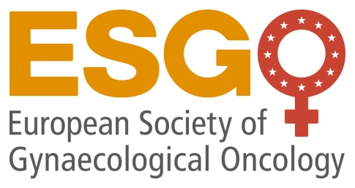
ESGO Rules for Endorsement of Scientific Meetings

Policy
ESGO is committed to spread and share knowledge in the field of gynaecological oncology and is achieving this mission endorsing the academic scientific meetings/courses. Each year ESGO supports limited number of meetings, face2face or virtual, organized by:

- Local partner (hospital / University/ Institution) - upon a request of individual ESGO member with activated membership.
- ESGO Task Forces or related Networks
- National society for Gynecologic Oncology or Gynaecology & Obstetrics
- Other Societies related to gynaecological cancer (sister societies, e.g., ESMO, ESTRO, ESP, IPOS, etc)

In general, ESGO endorses European meetings, but may also consider endorsing non-European meetings if application comes from a non-European ESGO member, or a National Society.
All applications are reviewed and decided upon by the Educational committee.

ESGO does not endorse meetings initiated by companies providing medical education as a core business.

In case of sponsorship from pharmaceutical industry, the meeting must be multi-sponsored and should not compete with any other ESGO educational activity, courses and/or event in dates and topics.

- ESGO provide the following support
a) Pure logo endorsement
b) Endorsement with ESGO speaker support
c) Joint session at sister society’s meeting
d) ESGO session at a national/international meeting

- For ESGO sessions, joint sessions and for endorsement with speakers, there is a dedicated ESGO representative as a contact person involved in the scientific programme.

The ESGO input:
- Granting the ESGO logo for use in all materials reflecting endorsement
- Assisting with composition of the scientific programme in case of joint sessions
- Economic support of ESGO speakers may be considered only for meetings held in middle and low income countries subject of budget available
- Providing the ESGO promotional materials.
- Promoting event at the Meeting calendar of ESGO website and through other promotional channels (subject of mutual agreement)

Local organizer input:
- Responsibility for all organizational and financial aspects of the meeting
- Preparation of the scientific programme in accordance with the proposal submitted to ESGO as a part of application.
- Reduced registration fees for ESGO members
- Provide visibility of ESGO and ESGO endorsement in reference to the event
- use of ESGO logo on all meeting material and meeting venue
- display of ESGO printed materials at the meeting (insert of ESGO brochures into participation´s bags and display at display tables) and/or provide a free booth to ESGO at the exhibition.
- ESGO must be advertised at the back cover side of the event Programme book
- ESGO slides and/or videos must be displayed between lectures or sessions
- A short time slot in the programme for presentation about ESGO given by ESGO speaker at the beginning of the meeting
Concrete visibility is a subject of agreement and signed Memorandum of Understandings between the organiser and ESGO office. Providing a short report together with 2-3 photographs that may be published through ESGO channels
- The organisers may propose or to be asked to share the scientific content of the meeting with ESGO (ppt slides, ePresentations, videos etc) for publishing at the ESGO eAcademy upon approval of speakers.

ESGO speakers input:
- Acting as ESGO ambassadors representing the society
- Promoting ESGO mission, activities and membership to the participants of the meeting. A short presentation about ESGO will be provided by ESGO Office.
- Contributing to the scientific programme by sharing their expertise, presenting lecture in accordance with a request from local organizers

Use of ESGO logo:
Please note that the society´s insignia (logo) is the property of ESGO. The insignia can only be used as designated and approved by the Society. Any use of the Society´s name must be approved by ESGO.

Application and communication process:

  - Applications should be submitted to ESGO Office at least 3 months in advance to allow proper review and approval process. In case of deeper involvement of ESGO in the scientific programme, more time may be requested.
Application includes:
- Details of the meeting (country, venue, title, dates, organizer, number of participants, contact person)
- Specification of requested type of endorsement/support (ESGO session, joint session, endorsement with ESGO speaker support, pure endorsement)
- Preliminary scientific programme
- List of suggested topics for ESGO speakers (if required)
- Official letter of national/sisters´ society requesting the endorsement (if applicable)

- Upon an approved application, applicant and ESGO sign Memorandum of Understanding that specifies the mutual agreed cooperation. The applicant is responsible to instruct the professional congress organizer/agency to act in compliance with the signed MoU.

Applications must be sent to adminoffice@esgo.org.
Application form is available at https://www.esgo.org/attend/esgo-endorsed-meetings/.

ESGO Office must be included in all related communication.

