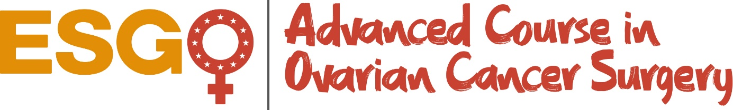

Hamburg, Germany, December 5-7, 2019
Preliminary Scientific Program

Day 1, Thursday December 5, 2019
Theoretical Lectures
11:30 | Welcome – Purpose of the masterclass
 | Session 1
12:00 | Modified posterior exenteration and Excision of the pouch of Douglas sparing the rectum
12:30 | The aim of cytoreduction in ovarian cancer surgery
12:50 | Science of tissue management
13:10 | Discussion - Interaction
13:30 | Lunch
 | Session 2
14:10 | Evaluation of the extension of the disease
14:30 | Para-aortic lymphadenectomy
14:50 | ESGO Guidelines and Recommendations in Ovarian Cancer surgery – Quality indicators
15:10 | Discussion - Interaction
 | Session 3
15:25 | Preoperative and Postoperative evaluation of the advanced ovarian cancer patient
15:45 | Role of ICU
16:05 | Nutrition
16:20 | Morbidity and postoperative outcome
16:40 | Stomach mobilization – Resection – Placement of J-tube
17:00 | Discussion- Interaction
17:15 | Coffee break
 | Session 4
17:45 | Liver mobilization & Resection of cardiophrenic nodes
18:05 | Diaphragm stripping – resection – repair
18:25 | Splenectomy and D- Interactionistal Pancreatectomy
18:45 | Wrap up Day 1

Day 2, Friday December 6, 2019
Theoretical lectures
 | Session 5
8:00 | Indications and use of HIPEC
8:20 | Dissection of Porta Hepatis, Celiac Trunk and Techniques for Cholecystectomy
8:50 | Discussion - Interaction
9:00 | Coffee break
Live Surgery 1 and 2 Transmissions
9:15 | 2 Live Surgeries Transmissions
 | Discussion – Interaction
13:30 | Lunch
 | Theoretical lectures continue
14:30 | Bowel preparation
14:50 | Bowel surgery
15:10 | Ureteral reconstruction and Urinary conduits
15:30 | Video Assisted Thoracoscopic Surgery (VATS)
15:50 | Discussion – Interaction
16:10 | Wrap up Day 2
Day 3, Saturday December 7, 2019
8:30 | Transfer to the Johnson & Johnson MEDICAL GmbH/ESI)
 | Cadaver-Lab Hands-on-Training
13:00 | Closing session, Wrap up of the course, evaluation, discussion, idea for improvements

